**PRACTICAL - 3**

[Click here to fill form](https://forms.gle/D3rQrCib83FbwzNe8)



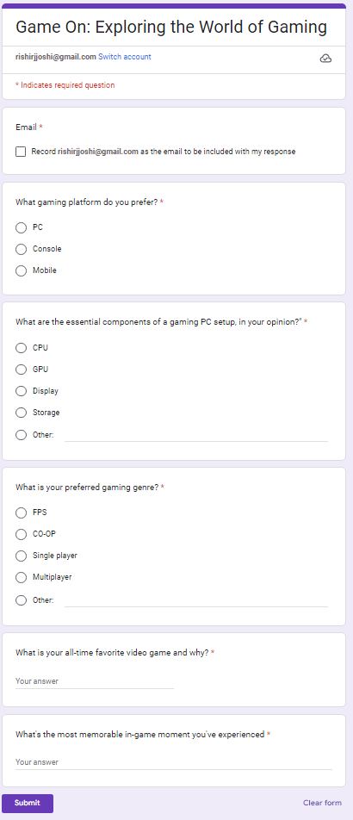

Signature of Faculty: __________ Date: ________